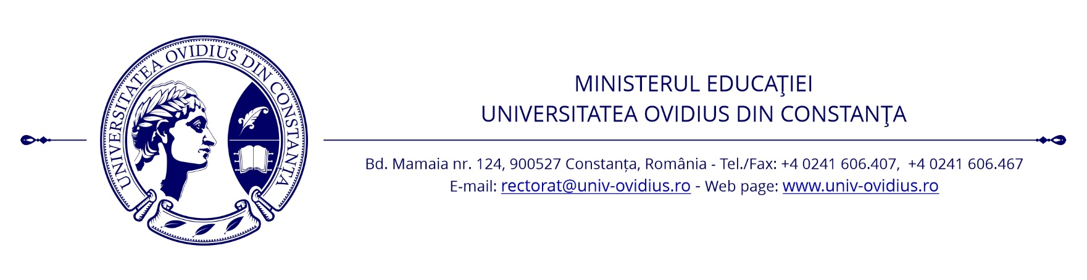

OVIDIUS UNIVERSITY ANNALS, SERIES PHYSICAL EDUCATION AND SPORT SCIENCE, MOVEMENT AND HEALTH
Our JOURNAL is nationally acknowledged by C.N.C.S.I.S., being included in the B+ category publications, 2008-2010.
1996-2012: ISSN 1224-7359;
2013: ISSN 2285-777X; ISSN-L 2285-777X; ISSN online 2285-7788
Periodicity for each year: Issue 1-January, Issue 2-June, Issue 2 Suppliment-September
The journal is indexed in: EBSCO/SPORTDISCUS, INDEX COPERNICUS, DOAJ, GALE, SCIPIO, ERIH PLUS

OFFICIAL INVITATION
We are honored to offer to do part as a reviewer at our scientific journal ”Ovidius University Annals, Series Physical Education and Sport/Science, Movement and Health”.
Please fill the adhesion reviewer and return scanned by our journal:
e-mail to: analefefs@univ-ovidius.ro
tel/fax at 004 0241 640443

Editor-in-chief
Ionel MELENCO, PhD Professor
Faculty of Physical Education and Sport,
Ovidius University of Constanta, ROMANIA

